Brewmaster Fan assm
Uninstalled
- Take the fan assembly out of the box  - Remove the plastic cover  - Place on a hard flat surface (stand it on its base)  - Grip the pulley with one hand and the hub with the other  - Apply force in the direction shown above to ensure the hub is securely tightened | 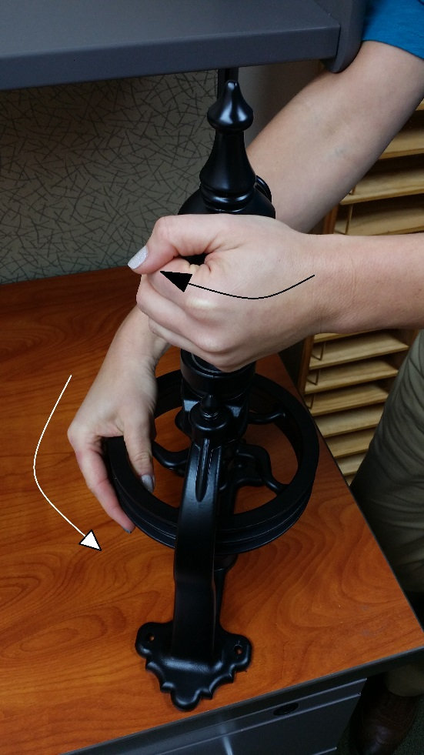
- Open the packet that contains the retention collar | 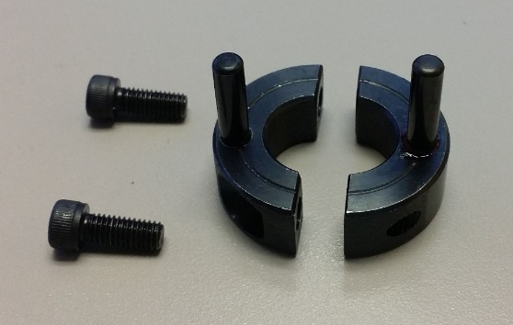
- Line up the pins as shown. The pins should go up into the hub
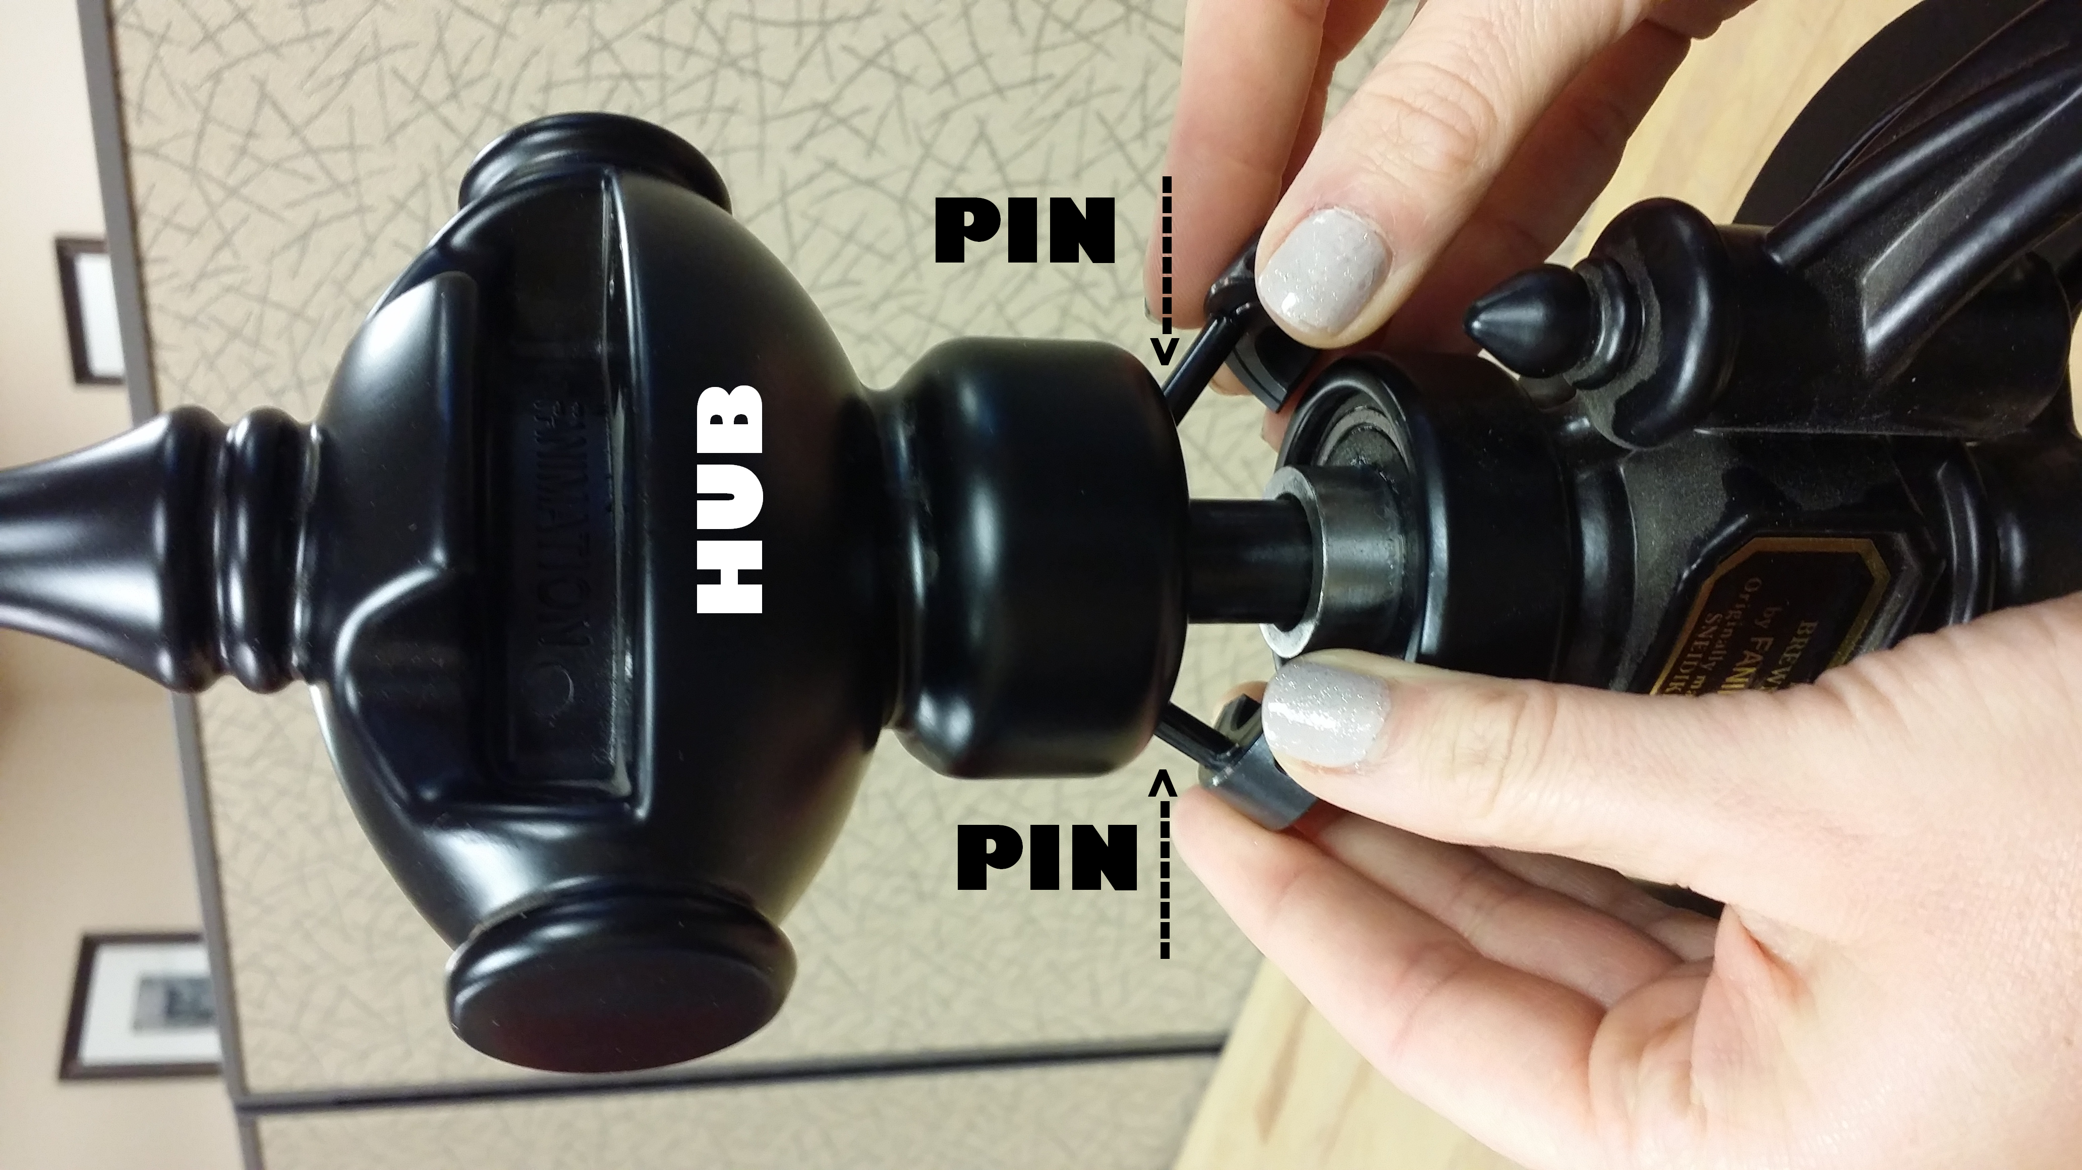
- Seat and affix the collar to the shaft with the socket head screws as shown  - Lightly tighten the two screws to keep the collar even  - Tighten the two screws as tight at possible using the Allen wrench supplied |  | 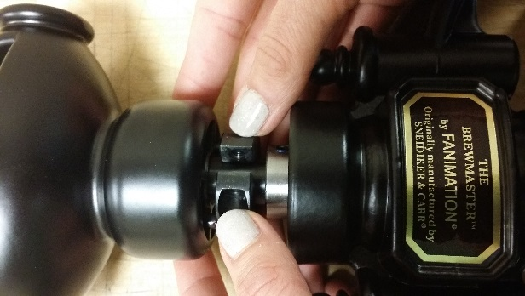
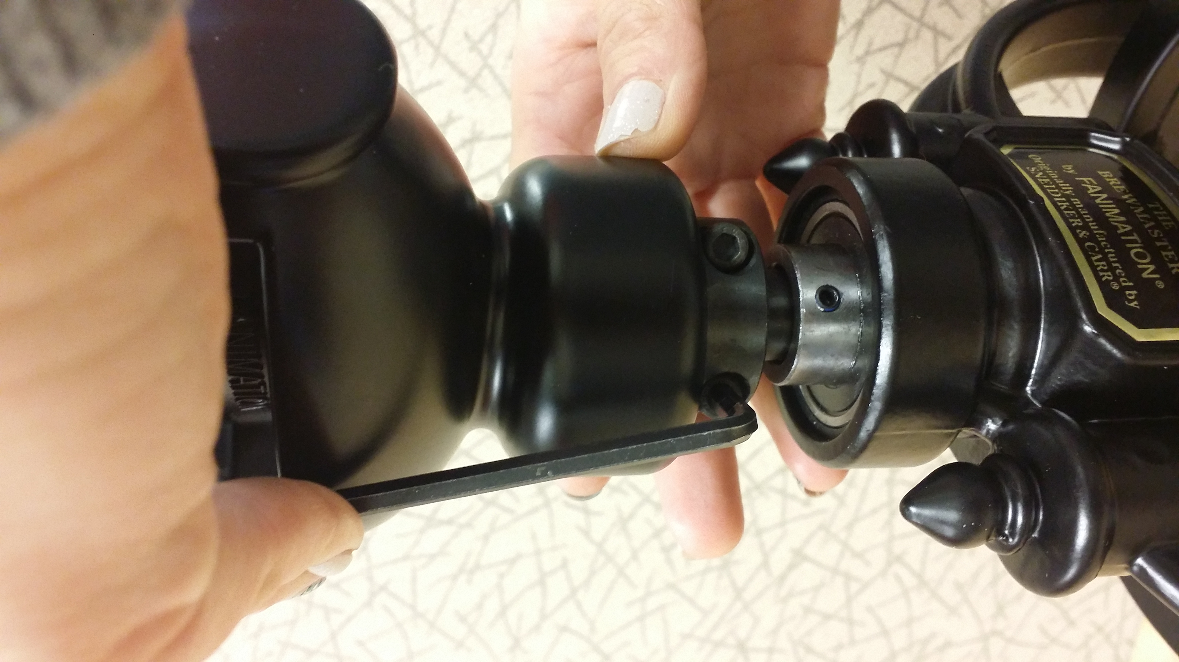
Rev 1.3
12/11/2014

