Brewmaster Fan assm
Installed system
- Grip the pulley with one hand and the hub assembly with the other.  - Apply force in the direction shown to ensure the hub is securely tightened | 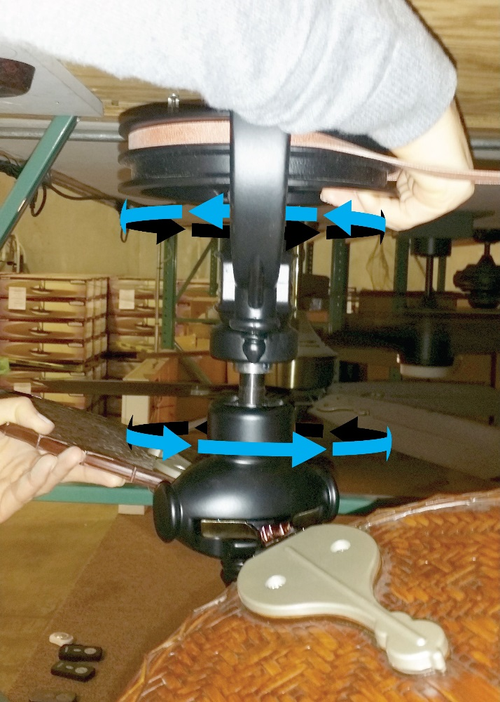
- Separate the halves of the retention collar with the 5/32 Allen wrench supplied (do not misplace the screws)  - As shown at the right, place the pin sides down into the hub | 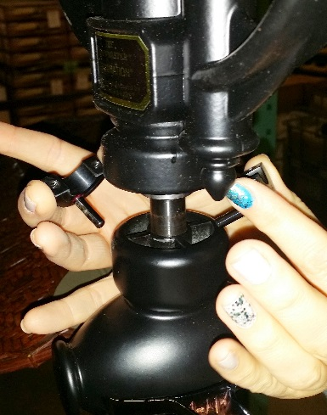
- Be sure the collar is seated against the hub with the pins down into the hub.  - Lightly tighten both screws until they are just snug to keep the halves straight.  - Tighten the two screws as tight as possible using the Allen wrench supplied with the retention collar.  Now that the retention collar is installed securely, operation of the system may be resumed.  Any questions or concerns can be addressed by email, fax, or phone  Email: recall@fanimation.com  Fax: (317) 536-3202  Phone: (866) 567-2055 | 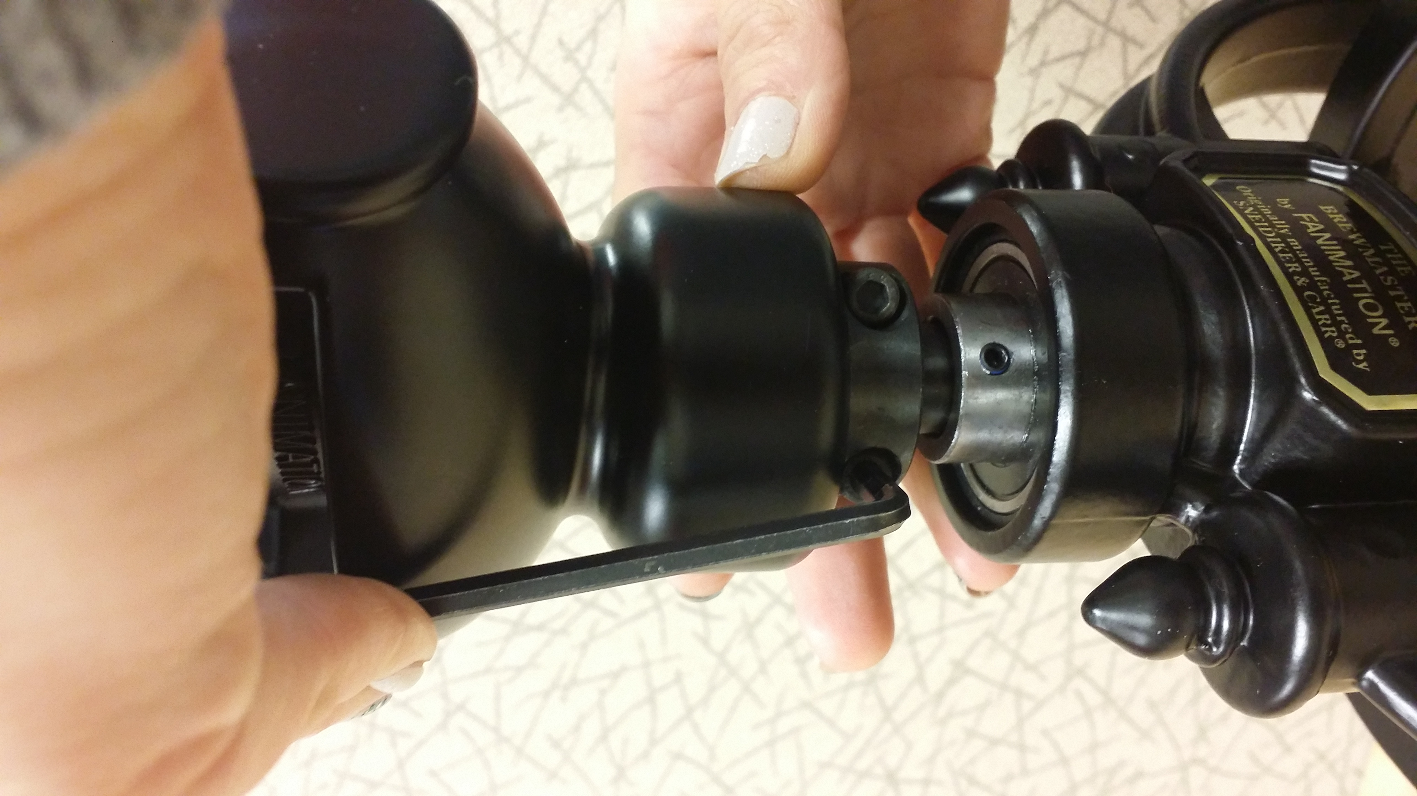

Rev 1.1
12/11/20

